DAA LAB PROJECT REPORT

Name Roll Number Section Batch
Mansi Jumde 09 A3 B1
Khushab Likhitker 07 A3 B1
Radhika Joshi 35 A3 B3

GitHub Link

https://github.com/Mansi-Jumde/Travel-and-Logistics.git

Title
Travel and logistics , find Visualizer using Bellman-Ford Algorithm in Python

Objectives
- To design a Python-based application that calculates the shortest route between cities.
- To implement the Bellman-Ford algorithm for route optimization.
- To handle negative edge weights and detect negative cycles in graphs.
- To use memoization to store previously computed routes for efficiency.
- To visualize computed routes using Python libraries like NetworkX and Matplotlib.

Introduction
Transportation and network optimization problems often require finding the shortest route between multiple cities or nodes.
This project simulates a city road network as a weighted directed graph where:
- Nodes (Vertices) represent cities.
- Edges (Weights) represent roads and their distances.
The project consists of two Python modules:
- Route_Backend.py – Computes shortest paths using the Bellman-Ford algorithm.
- Route_Visualizer.py – Displays a graphical representation of the routes using NetworkX and Matplotlib.
Python was chosen due to its:
- Simplicity and readability
- Strong data structure support (lists, dictionaries)
- Availability of visualization and data-handling libraries
The system calculates the optimal path, stores results in CSV files, and generates a visual representation of the road network.

Algorithms / Technique Used

Algorithm Name:
Bellman-Ford Algorithm with Memoization

Algorithm Steps
- Input Graph:
Accept a list of cities and their road connections (edges) with distances.
- Initialization:
Set distances of all vertices to infinity (float('inf')), except the source = 0.
Edge Relaxation:
For each vertex, check all edges (V–1 times) and update distances if a shorter path is found.
if dist[u] + w < dist[v]:
dist[v] = dist[u] + w

- Negative Cycle Detection:
If any distance can still be updated after V–1 iterations, a negative cycle exists.
- Memoization:
Store computed distances in a 2D list (memo[src][dest]) to reuse for repeated queries.
- Output:
Display shortest paths and export results to route_results.csv and route_edges.csv for visualization.

Explanation
- Backend (Route_Backend.py) implements Bellman-Ford to compute the shortest route between cities.
- Visualizer (Route_Visualizer.py) reads CSV files, constructs a directed graph, and displays it graphically.
- The visual graph highlights:
  - Source city – Red node
  - Reachable cities – Green nodes
  - Unreachable cities – Blue nodes
  - Shortest route edges – Green arrows with weight labels

Flowchart
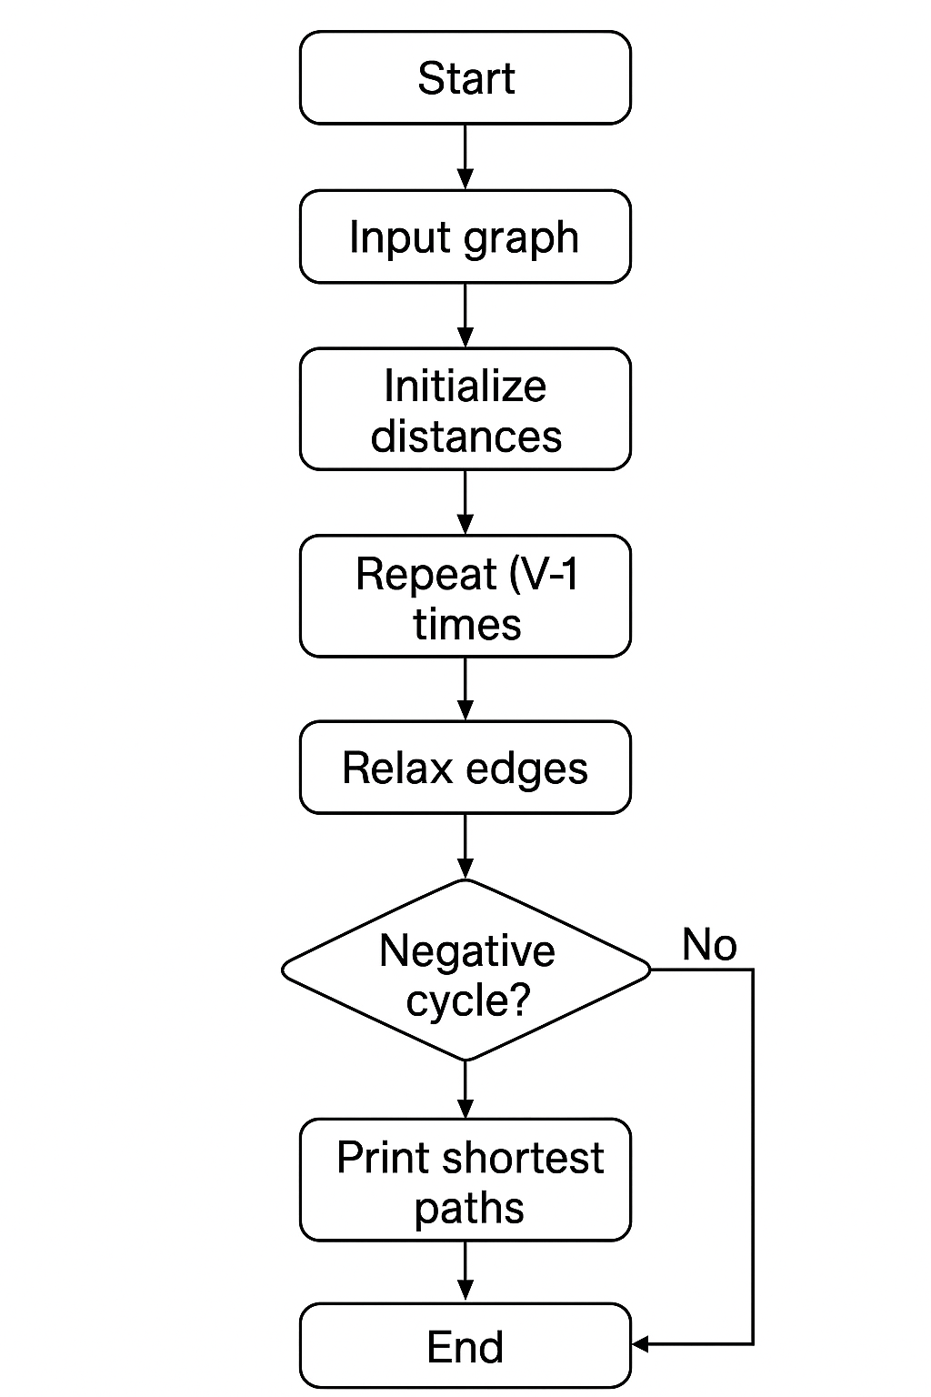

Python Techniques Used
Technique | Description
Dynamic Programming | Computes shortest distances using repeated relaxation
Memoization | Stores computed results to avoid recomputation
File Handling (CSV) | Saves results for later visualization
NetworkX Library | Creates and analyzes directed weighted graphs
Matplotlib Library | Visualizes nodes, edges, and routes
Pandas Library | Reads and writes CSV files efficiently

Time Complexity
Step | Complexity | Explanation
Edge Relaxation | O(V × E) | Each edge is processed for V–1 iterations
Negative Cycle Check | O(E) | One additional pass for cycle detection
Memoization Lookup | O(1) | Precomputed results reused instantly
Visualization | O(V + E) | Drawing all nodes and edges
Overall | O(V × E) | Efficient for small and medium networks

Results

Sample Input
A B 5
B C 10
D C 10
A E 5
E C 5
A D 20
F A 10
C F 5
B D 5
Enter source city: A

Sample Console Output
Enter number of cities and roads: 6 9
Enter city names:
City 1: A
City 2: B
City 3: C
City 4: D
City 5: E
City 6: F

Enter roads (SourceCity DestinationCity Distance):
A B 5
B C 10
D C 10
A E 5
E C 5
A D 20
F A 10
C F 5
B D 5

Enter source city: A

Shortest Distances from A:
----------------------------------
A 0
B 5
C 10
D 10
E 5
F 15
Data saved to 'route_results.csv' and 'route_edges.csv'.
Run 'python Route_Visualizer.py' to see the graphical output.
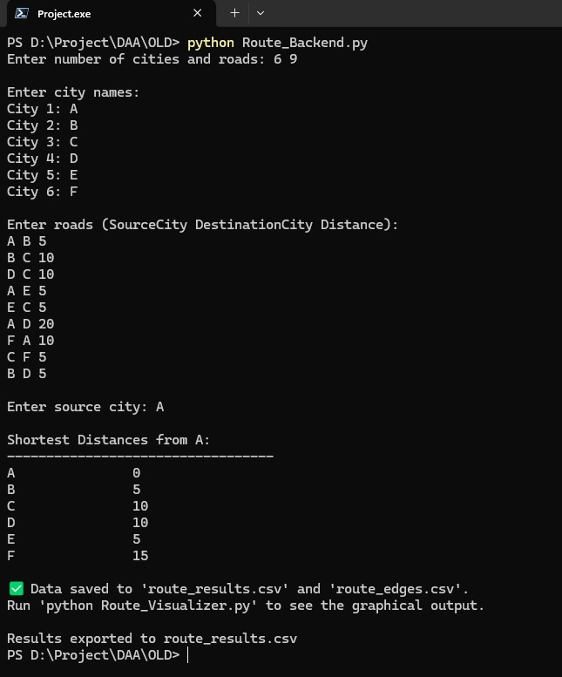

CSV Output (route_results.csv)

City,Distance
A,0
B,5
C,10
D,10
E,5
F,15

Graphical Output
- Source City: A (Red Node)
- Reachable Cities: B, C, D, E, F (Green Nodes)
- Shortest Path Edges: Green Arrows with Distance Labels
- Visualization displayed using NetworkX and Matplotlib
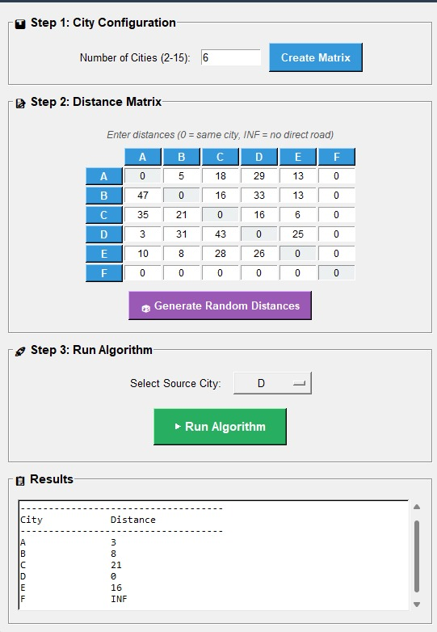
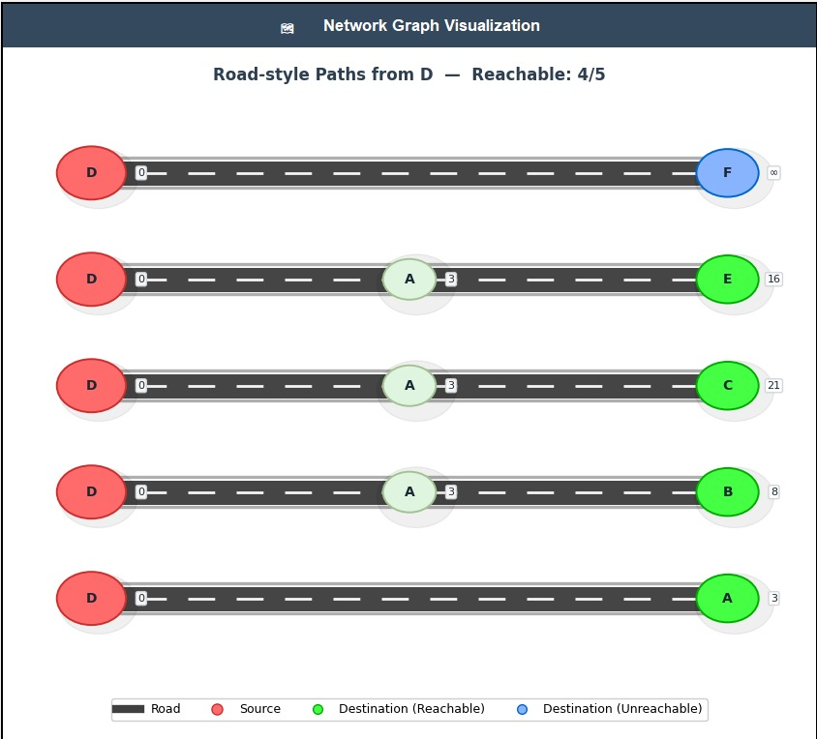
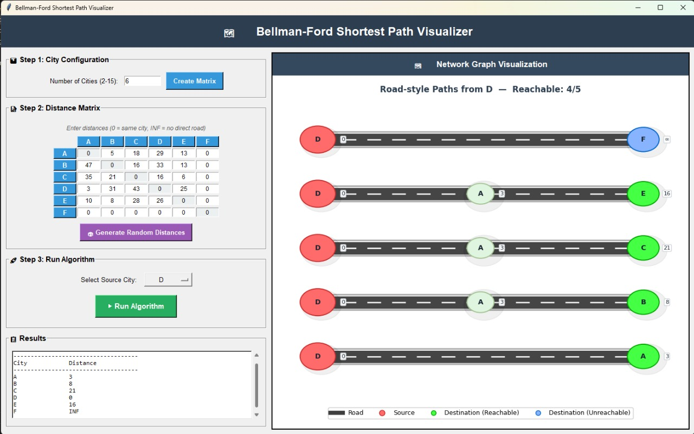

Discussion
- The backend correctly computes the shortest distances from the given source city using the Bellman-Ford algorithm.
- The visualization module provides a clear, color-coded view of the optimal routes.
- The memoization system reduces repeated computation time for the same source.
- The integration of CSV export and NetworkX graphing makes the system efficient and interactive.
- The system effectively handles directed routes and varied edge weights.

Conclusion
The project successfully demonstrates the implementation of the Bellman-Ford Algorithm in Python for finding the shortest routes between cities.
It efficiently handles negative edge weights and avoids redundant calculations through memoization.
The integration of visualization tools enhances clarity and understanding of route structures.

Future Scope
- Add a Graphical User Interface (GUI) using Tkinter or Streamlit.
- Integrate with Google Maps API or OpenStreetMap for real-world visualization.
- Extend the project to handle multi-source or all-pairs shortest paths (using Floyd–Warshall algorithm).
- Deploy as a web-based route planner using Flask or FastAPI.
- Incorporate real-time traffic or distance updates from APIs.

